**PATENT QUESTIONNAIRE**

*A patent specification is a description of the invention. The specification must describe the invention in sufficient detail to enable a person of ordinary skill to put it into effect. It should also identify the novel feature(s) of the invention, and the advantages of that or those feature(s).*

*Although you may be familiar with the technology of the invention, please bear in mind that future readers of the specification, such as patent examiners, may not have the benefit of your background knowledge and expertise.*

*This questionnaire is intended to elicit sufficient information to enable us to prepare a patent specification for the invention and/or to assess the patentability of the invention. Please answer any applicable questions as fully as possible.*

**THE INVENTION**

1. What is the general field of the invention? Realtime Technical or Engineering type Measurement used in Tailings Management. (Note: UQ IP access specifically relates to tailings management)
2. What is the intended function, purpose or aim of the invention? To measure, in real-time, on a mobile equipment, the physical characteristics (ie. density, water content etc) of in situ mine tailings
3. What is the problem that the invention is intended to overcome, and/or what are the advantages of your invention? The problem is that insitu tailings physical characteristics are either estimated from tailings production data or require manual sampling often followed by laboratory characterisation. Ultimately, decision making becomes a balance between estimation and cost. As, data capture is a slow process (days - weeks) and often limited by physical access it is also probable that some important data is missed due to these constraints impacting on the quality of the tailings management solution. Our solution: the real-time sensor, will be mounted to an Archimedes screw tractor or vehicle to take readings every few seconds (variable and specific to the tailings parameters) as the vehicle moves along without the sensor physically touching the tailings. With this sensor it will be possible to get information from the entire tailings facility without stopping to take physical samples. It will also not require a human to be on the vehicle to take samples.
4. Is there any particular aspect of, or step in, your invention which overcomes the problem or results in those advantages? The sensor is contactless, continuous, and autonomous and once calibrated, can send real-time information and reports to the end user without physical intervention or manual manipulation. Additionally, the data available is orders of magnitude greater than manual processes and significantly more accurate that estimation techniques.
5. Please provide a detailed written description of how your invention is constructed or implemented, including drawings or sketches (if applicable).

The Dielectric Antenna is a composite system (figure 1) made up of the following physical components (figure 2.1 – figure 2.3):

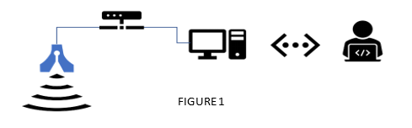

* Vivaldi Antenna – Operating at a frequency of 0.6 GHz to 1 GHz;
* Vector Network Analyser (VNA) – Used to send and receive signal to and from the Antenna. Multiple ports will increase accuracy of reading;
* Windows Computer (not displayed in figure) – Runs the VNA controller software suite (both Megiq and Python) and collects the log files over USB connectivity;
* Linux Computer (Arduino) – hosts the Calibration and Operation interface for the VNA and Antenna and controls the mechanical actuator;
* Mechanical Actuator – is used to calibrate the VNA / Antenna at various heights;
* Absorbing Material – this is a unique material used to perform zero calibration on the Antenna and VNA.

Absorbing Material

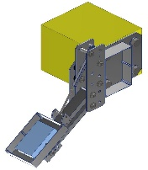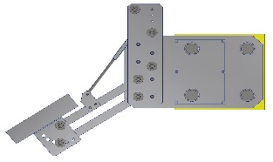

Vivaldi Antenna

Vector Network Analyser

Mechanical Actuator

Linux Computer (Arduino)

FIGURE 2.1

FIGURE 2.2

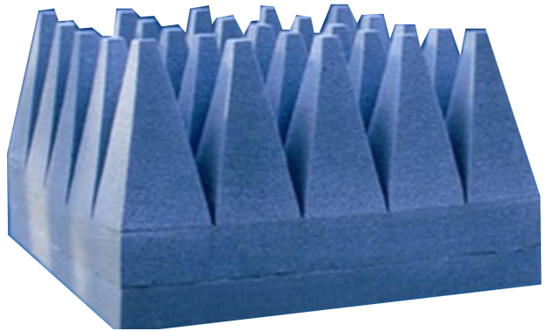

FIGURE 2.3

When mounted to the MudMaster (figure 3.1 & figure 3.2) and powered and calibrated, the Dielectric Antenna will send a radio frequency at a pre-set interval toward the tailings and then measure the reflection of the return signal. The result is logged data in the form of measured permittivity of the material at that given point in time and geographic location.

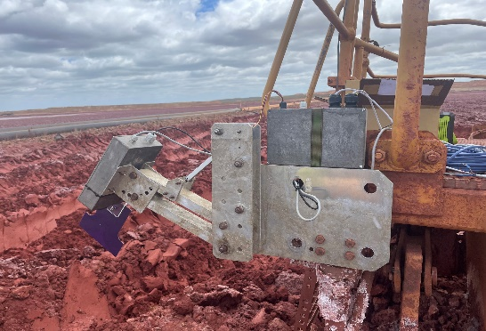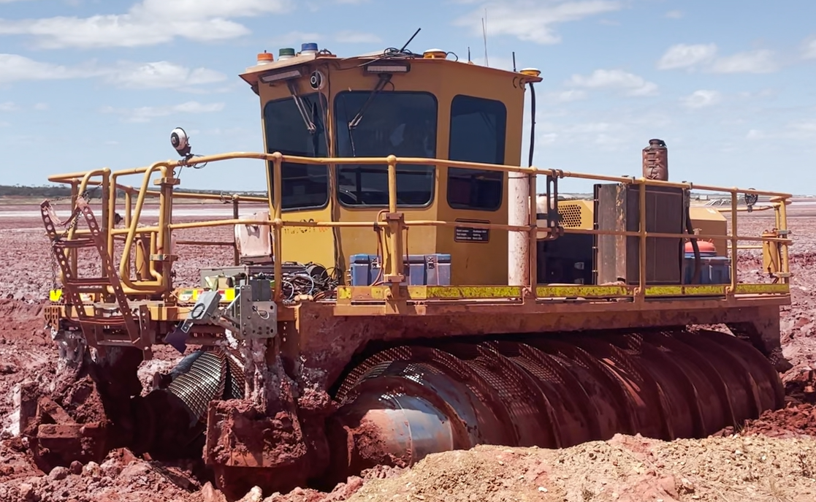

FIGURE 3.1

FIGURE 3.2

Prior to logging, a sample is required to characterise the calibration of the system. This provides a conversion from permittivity (as logged by the system) to density and water saturation.

This data is later transposed to a data analytic report in the form of a heat map (figure 4 -as taken in Nickle Tailings site).

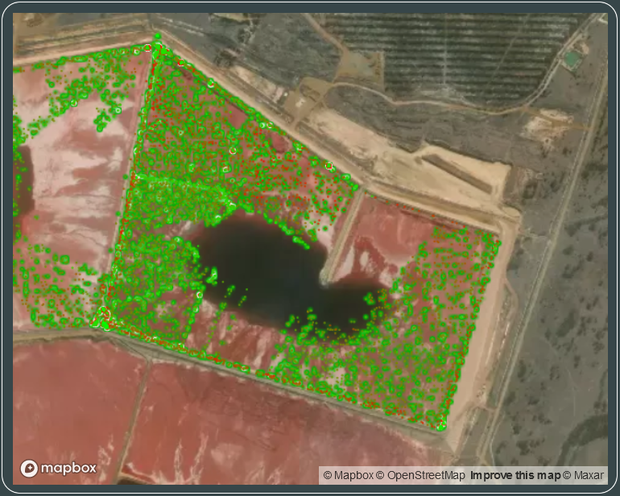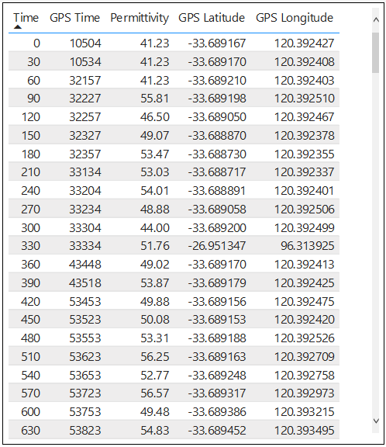

FIGURE 4

The result is a display of the average permittivity, density and water saturation of the tailings in a given location.

Several controlled trials were undertaken in the workshop using a stationary MudMaster with an antenna suspended over a 9m2 tailings simulated pond. The results led to a field trial.

**Nickle Tailings**

Trials were conducted with the Dielectric Antenna system mounted on MMX using the following procedure:

* Zero calibrate the Antenna using dedicated Absorbing material and running the calibration setting using the system interface on the computer;
* Set Dielectric Antenna to Run using the system interface on the computer;
* Operate the MMX (MudMaster) per the tailings management plan, during this time the data will be collected on a 10 second interval (figure 3.1);
* Once the data was collected, it was automatically processed and presented in the Data Analytics software (figure 4), displaying permittivity.
* Physical samples were taken from the tailings and tested in the lab to acquire soil characteristics. The results are used to overlay the results of the Dielectric Antenna to predict the Density and the Water Saturation. This stage would usually be executed prior to deploying the Dielectric Antenna.

1. Are there any possible variations or modifications of the invention, or additions thereto, which you would also like protected? No, this remote sensing capability is used in the food industry, but we would like our application in tailings to be protected.
2. Are there any other uses of your invention which you wish to cover? no
3. List in order of importance, the features or steps of your invention which you would like to prevent others from using, selling or manufacturing.
   1. Use of a dielectric sensor in measuring the physical characteristics of tailings
   2. The calibration method used for every site to calibrate the physical tailings to the sensor antenna is a standardised process should be protected. Data gathered without the calibration capability is of limited value.
   3. The report gathered from the high-density real-time data received creates a heatmap of data with a before and after image to show how changes in the physical characteristics of tailings occur – we would want this capability to be protected. Even if competition is using a manual spot point data gathering method (at a lower data density), we want the heatmap visual protected.
   4. The fact that this sensor is contactless is important

**PRIOR ART**

1. Have you searched for similar apparatus or methods (“prior art”)?

*[If not, do you wish us to conduct a search?]*

We were not aware of any similar technology used in tailings management. However, outside of this we have relied heavily on University of Queensland advice and capability for prior art. A search would be of confirming value.

1. What relevant prior art are you aware of?

*[If none, go to question 13]*

1. Please describe any disadvantages or problems associated with the prior art.

Prior art as we see it is the application of well established and defined conventional manual tailings management sampling techniques. This requires manual sampling, often slow and at significant risk due to unpredictable access conditions.

1. What are the features of your invention which you believe to be novel over the prior art?

The remote nature of access, calibrated directly to the physical tailings properties, allowing a significant increase in data capture at minimal risk.

**OTHER INFORMATION**

1. List the countries in which you may require patent protection.

Australia, Chile, Brazil, Peru, Mexico, USA, Canada, EU, Africa?

1. Has the invention been disclosed publicly, e.g. by public display, sale, advertising, description in published document, etc.? (If yes, please provide details).

No

1. Has the invention been sold, licensed or used commercially? (If yes, please provide details).

No

**CLIENT DETAILS**

1. Please provide full contact details of the person/company to whom correspondence and invoices are to be sent, and from whom we are to seek instructions in this matter.

*[Include full name, street and mailing addresses, telephone and fax numbers, and email address, ABN or ACN (where applicable)]*

**PATENT APPLICANT DETAILS**

1. In whose name(s) will the patent application be filed? In other words, who owns the rights to the invention? (Please provide full name, street address, nationality and ACN if applicable).

There may be a requirement to define/highlight the source of the base IP?

**INVENTOR DETAILS**

1. Please provide the full name, residential address, nationality and country of residence of each inventor.

DS should be listed but of course assign to Phibion, DF, Jacob. We may need to incorporate the research from UQ as to the suitability of application - this will need additional conversation with UQ.

1. If there are two or more co-inventors, please identify the respective contribution of each inventor (if possible).
2. In which country was the invention made?

Australia

1. Did any inventor make the invention in the course of employment duties or pursuant to a contractual obligation, or is any inventor under an obligation to assign or licence rights in the invention to another party? If so, please provide details.
2. If the patent applicant of question 17 is different from the inventor(s) of question 18, how did the applicant derive the rights to the invention from the inventor(s)?

*[For example, was the invention made for the applicant by the inventor(s) in the course of his/her/their employment duties to the applicant, or was the invention otherwise assigned from the inventor(s) to the applicant?]*

1. If the applicant is different from the inventor(s), we recommend that there be a written assignment from the inventor(s) to the applicant (even if the invention was made in the course of employment duties). Do you wish us to prepare an assignment document?